In this exercise, we evaluated the ticket price of the Big Mountain Resort to determine if price increases, additional features or operating cost reductions could be implemented to increase the overall revenue for the resort. The current pricing strategy is at a premium above other markets in its segment, but it is not known how well they are capitalizing on their facilities.

The first step in the analysis began with a review of the data available. The Big Mountain Resort was found in the data and contained values for all relevant features. There were missing values found and some incorrect values, some of which would not impact the overall analysis and some which required some additional action. Data was visualized across the variety of features reported.

Missing data ultimately led to the selection of Adult Weekend Pass Price as the primary target variable as there was a strong correlation between Adult Weekend and Adult Weekday prices.

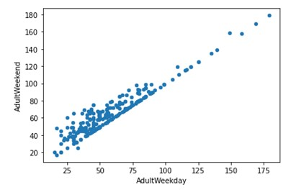

*Figure 1: Linear regression of Adult Weekend price vs. Adult Weekday price.*

Exploration of the state summary data identified some interesting information, but ultimately was found not to be a key feature in this analysis and all states were treated equally. To evaluate how ticket prices vary with other numeric features, scatterplots were created to identify correlations. A few scatterplots of how people are transported show some unexpected trends.

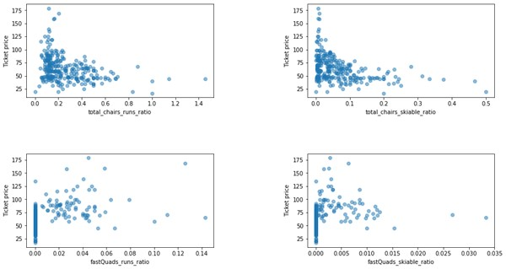

*Figure 2: Scatterplots of transportation vs. runs or skiable area ratios*

It seems that the more chairs a resort has to move people around, relative to the number of runs, ticket price rapidly plummets and stays low. What may be happening is an exclusive vs. mass market resort effect; if you don't have as many chairs, you can charge more for your tickets, although with fewer chairs you're inevitably going to be able to serve fewer visitors. The price per visitor is high but the number of visitors may be low. Something very useful that's missing from the data is the number of visitors per year. It also appears that having no fast quads may limit the ticket price, but if your resort covers a wide area then getting a small number of fast quads may be beneficial to ticket price.

With this information, two models were created to predict the ticket price based on a series of features. Both models were evaluated on their ability to predict ticket price. The Linear regression model resulted in an R2 of 0.6659027042624323 for the test data and was further refined with cross-validation approach and reached an R2 of 0.76903383. The Random Forest Model was also utilized using with / without feature scaling and both the mean/median as strategies for imputing missing values. The Random Forest Model delivered a list of features ranked by importance which aligned well with the Linear model. The random forest model has a lower cross-validation mean absolute error by almost $1. It also exhibits less variability. Verifying performance on the test set produces performance consistent with the cross-validation results. Therefore, the Random Forest model was selected.

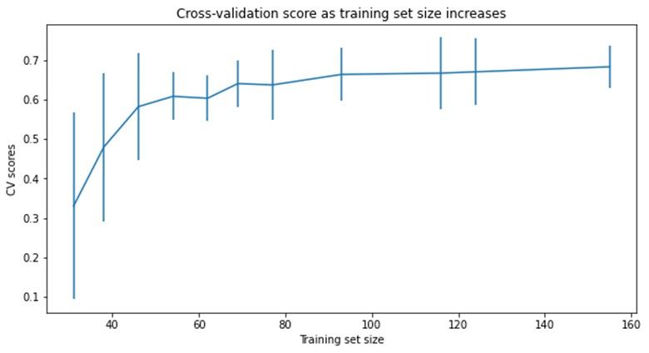

*Figure 3: Learning curve for training set data size*

This model was also used to confirm that there is adequate data. The chart indicates that there's an initial rapid improvement in model scores, but levels off by around a sample size of 40-50.

The modeling was further used to evaluate the four business scenarios.

1. Permanently closing up to 10 of the least used runs
2. Increase the vertical drop by adding a run to a point 150 feet lower down but requiring the installation of an additional chair lift to bring skiers back up
3. Same as number 2, but adding 2 acres of snow making cover
4. Increase the longest run by 0.2 mile to boast 3.5 miles length, requiring an additional snow making coverage of 4 acres

Scenario 1 yielded results of no impact to significant impact depending on the number of runs closed. Both Scenario 2 and 3 yielded an increase in ticket price. The last scenario resulted in no impact. While this is useful information, the model can further be utilized to evaluate a range of potential situations and the impact on ticket price.